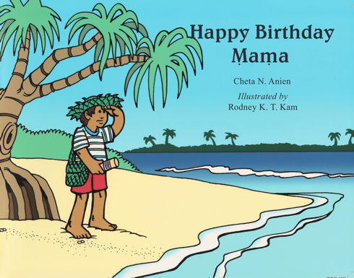 | Focus on the cover  “Let’s see, what is on the cover of this book? Who do we see? What do you think this story will be about?  Make predictions  “Look, the boy is standing next to the water, what do you think is he looking at? And what does he have in his hand? What do you think he is going to do? Let’s open the book to find out”
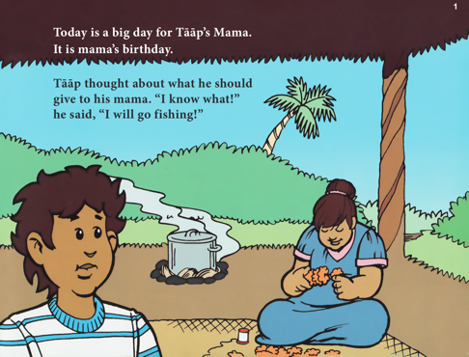 | Name and describe what you see; use descriptive words and explanations, and ask questions to help your child understand new words or concepts:  Look, there is a big pot on the fire. What is that coming out of the pot? Is that steam? This happens when something is very hot inside the pot. What do you think would happen if you touch it? What do you think is inside the pot? What will they do with it?"
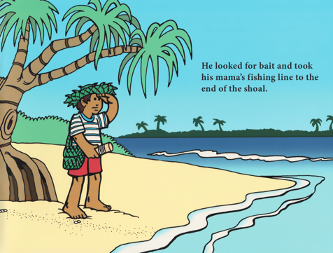 | Make connections between the story and your child’s experiences  “Look, he is carrying a bag over his shoulder. You also carry a bag when you go to...What do you normally carry in your bag? What do you think might be in his bag?”
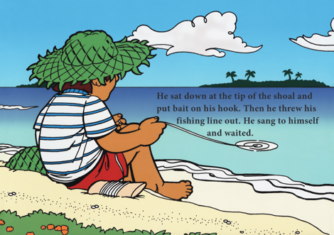 | Name and describe what you see; use descriptive words and explanations to help your child understand new words/concepts:  “Look, he is holding a fishing line in the water. He is trying to catch a fish. Why would the fish bite his fishing line? He put some bait on the line, to attract the fish swimming in the ocean. Do you know what bait is?”
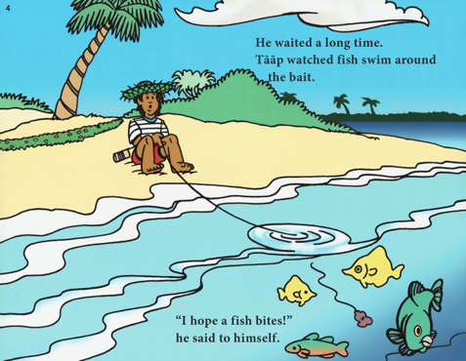 | Ask Who, What, Why, Where, How questions to help your child think about the story, and what is happening:  Who is sitting on the sand?  Why is he sitting there?  What does he have in his hands?  Where are the fish?  How will the boy know if he has caught a fish?  Talk about similarities/differences  “Look, there are fish in the water. How many fish can you see? Do they all look the same? Look, these to fish are the same colour (yellow), but are they the same size?”
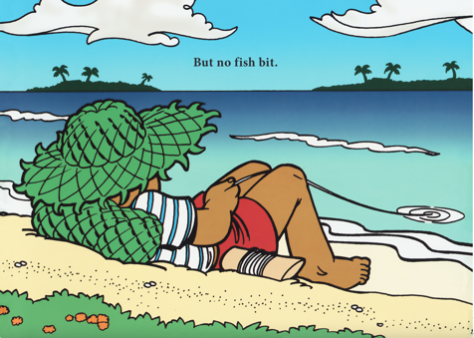 | Pause and reflect  “Let’s see, what has happened so far? Taap has come down to the beach, why is he there? What is he trying to do? Has he succeeded?”  Make predictions  “What do you think is going to happen next? Do you think he is going to catch a fish? Why/why not?”
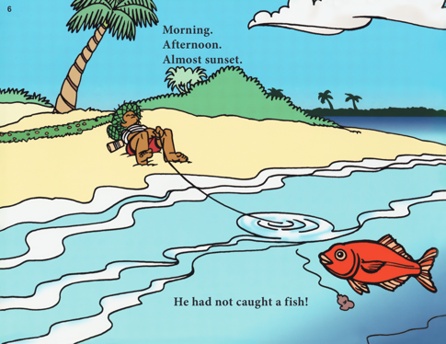 | Make predictions  “Look there is a big red fish swimming towards Taap’s line. What do you think is going to happen? Do you think the fish will bite the line?”  Thinking about perspectives  “Do you think Taap knows there is a fish swimming so close to his fishing line? I don’t think he knows because he is lying on his back and can’t see into the water. How will Taap know what the fish has bitten his line?”
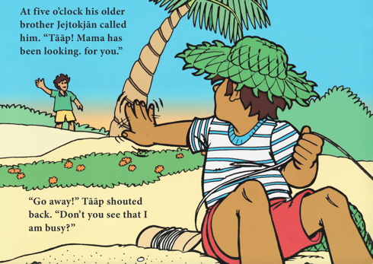 | Thinking about intentions  “What is that boy in the distance doing? (He is calling Taap). What do you think he is trying to tell Taap? (He wants Taap to come home). Why does Taap hold his hand up to the boy? (Taap doesn’t want to go home). What is Taap trying to do? (He is trying to catch a fish).”  Thinking about emotions/feelings  “How do you think Taap is feeling? Do you think he might be feeling frustrated because he hasn’t caught a fish yet, and he is being called home? Why do you think he wants to catch a fish? How do you think he will feel if he doesn’t catch a fish?”
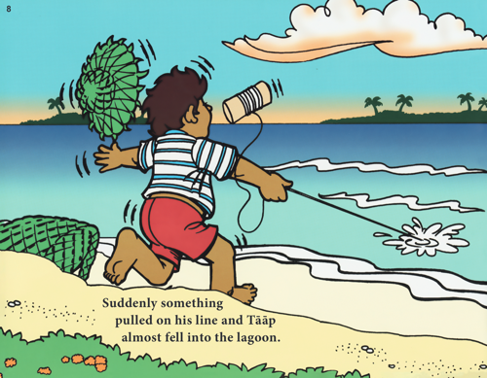 | Thinking about perspectives  “Do you think Taap knows he has caught a fish? How does he know?”  Name and describe what you see; use descriptive words and explanations to help your child understand new words/concepts:  “Look Taap is being pulled towards the water by his fishing line. That means that a fish has bitten his fishing line and Taap needs to work hard, using his hands to pull the fish out of the water”  Talking about feelings  “Do you think he expected it to happen, or was he surprised?”
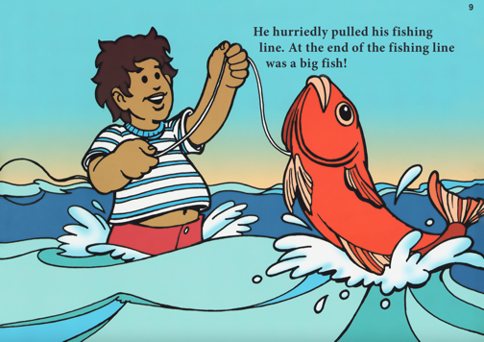 | Ask Who, What, Why, Where, How questions to help your child think about the story, and what is happening:  Where is Taap standing?  Why is he standing there?  What does he have in his hand?  How did he catch the fish?  Why is he smiling?
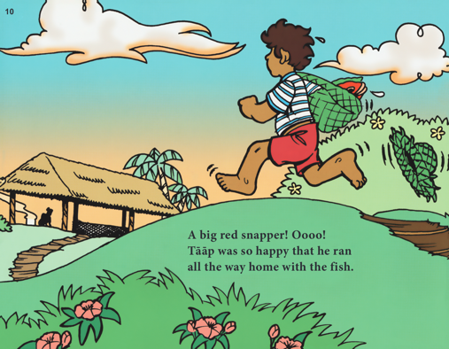 | Pause and reflect  “Let’s see, what has happened so far? Taap went down to the beach, to catch a fish. Did he catch it? What did he do after he caught the fish?”  Thinking about intentions  “Look, Taap is running. Why do you think he is running? What do you think he will do when he gets home?”  Thinking about perspectives  “Do you think Taap’s mother knows that Taap has caught a fish? I think she doesn’t know because she hasn’t seen him yet. How do you think she will feel when she finds out?”
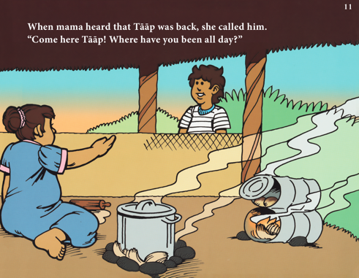 | “Look, Taap’s mother is calling him home. What has she been doing? What has Taap been doing? What do you think she is telling him?”  Make connections between the story and your child’s experiences  “Look, the colour of the sky has changed from blue to orange/pink. That means that the day is nearing its end. What do we normally do at this time of day?”
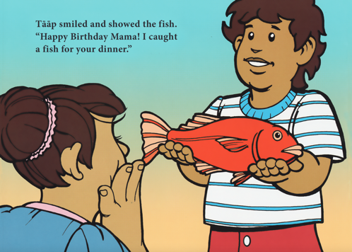 | Talk about the emotions in the pictures, and why the characters might be feeling the way the do.  “Look, he is smiling, holding out the fish to his mother. I think he is feeling proud that he caught the fish, especially since he had to wait so long before catching one”  “Look, his mother is holding her hands to her face [you can mimic the action for your child]. How do you think she is feeling? Do you think she expected her son to bring her a fish? How do you think she feels that he brought her the fish?”
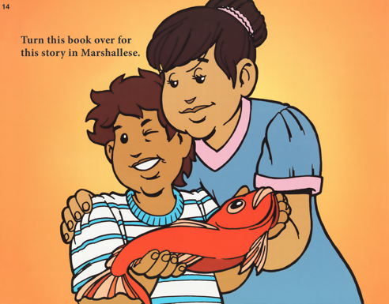 | Reflect on the story structure  “Look, here is Taap and his mother – she is hugging him while he is holding the fish. What happened in the beginning of the story? Did Taap have the fish at the beginning of the story? When in the story did he catch the fish? What happened next? And how did the story end?”

